**Create JSON file data using browser dev tools:**

1. Run the Search after Selecting the type dropdown.
2. Go to developer tools by using the keyboard shortcut Ctrl + Shift + I
3. Choose Network tab.
4. And choose the row starts with entities?t= from the table as below. Note: Sometime you might not able to see entities?t as below if that the case run the search again.

1. Click Preview tab and Right click on the values on the preview tab and copy.

1. Paste it in the notepad and save as JSON file type refer “CRD Register - Sample Data.json” and “SampleDataTemplate.json” file to get more clarity and save appropriately.

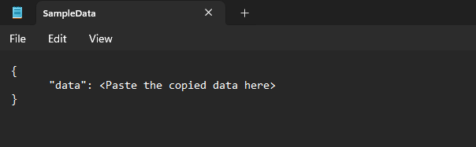

1. Now you will be able to extract json data to a table using the “PowerQueryExtraction.xlsx” file.
2. Change the path of your json file in power query advanced editor and refresh the query to get data in a table format.